

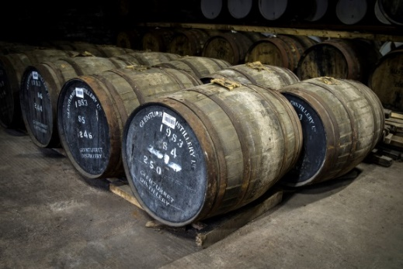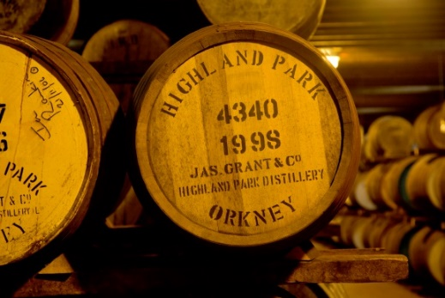

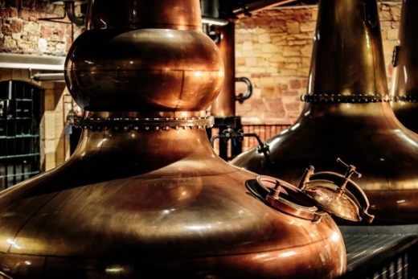

Whisky Focussed

Sample Itinerary

Day One

Holyrood Distillery

The first time since 1925 a single malt whisky distillery is located in the centre of Edinburgh. From the spirits they create unique visitor experience inside our 180-year-old railway goods shed-turned-distillery, everything they do focuses on creating amazing flavours that delight taste buds.

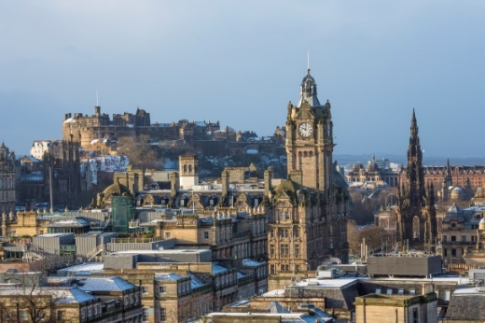

Holyrood Distillery

19 St Leonard's Ln,

Edinburgh,

EH8 9SH

W: <https://www.holyrooddistillery.co.uk/>

The Scotch Whisky Experience

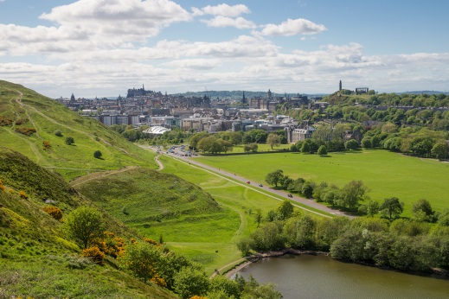A ‘must-visit’ Edinburgh attraction, The Scotch Whisky Experience will make your clients ‘Whisky experts’, with an unforgettable whisky tasting within The World’s Largest Collection of Scotch Whisky. Tours are held in 18 languages, and tasting options are available to suit every group, with a superb array of group dining options in the award-winning restaurant Amber Restaurant.

The Scotch Whisky Experience

The Royal Mile,

354 Castlehill,

Edinburgh,

EH1 2NE

W: [https://www.scotchwhiskyexperience.co.uk](https://www.scotchwhiskyexperience.co.uk/)

The Port of Leith Distillery

In the not too distant future, The Port of Leith Distillery will be sitting in a shiny new whisky distillery with underfloor heating on the Port of Leith. For now, however, they are located in a Stillhouse in Leith with a shed and gin still inside. Over the course of 75 minutes, they will tell your clients about their journey so far, how they devised and produce Lind & Lime Gin, why they ship their own sherry from Spain, and the various things that they are planning with their whisky. Your clients can enjoy a glass of their Oloroso Sherry, a Gin & Tonic and couple of their signature cocktails while you listen.

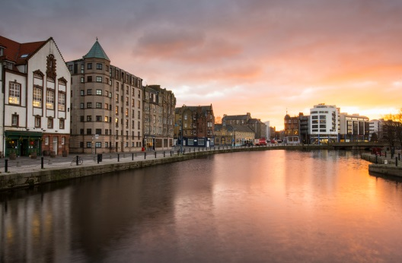

The Port of Leith Distillery

53 Tower St,

Leith,

Edinburgh

EH6 7BN

W: https://leithdistillery.com/

The Johnnie Walker Experience

Brand New Whisky Experience due to open on Princes Street in 2021. An Immersive visitor experience across three floors, with access to rooftop with stunning views across the city. Diageo produce over 100 individual scotch brands with the same care, skill and entrepreneurial spirit as these giants of our industry. Their leading brand is Johnnie Walker, the world’s best-selling scotch, but they also produce other high-quality blended brands such as J&B and Bell’s, along with a range of single malts, including Lagavulin, Talisker, Mortlach and The Singleton.

The Johnnie Walker Experience

Princes Street,

Edinburgh

W: <https://www.diageo.com/en/news-and-media/features/flagship-johnnie-walker-attraction-gets-green-light/>

Glenkinchie Distillery

Glenkinchie was founded in 1837, when 115 licensed distilleries were recorded in the lowlands, though their products would probably not pass muster today! Few parts of Scotland can boast of more history than this. They offer a daily transport service direct to the distillery from Edinburgh City Centre, the bus operates 7 days a week and departs at 10.00 and 13.30. Your clients can enjoy the behind the scene tour showing those unique areas that aren’t usually seen on regular tours.

Glenkinchie Distillery

Pencaitland,

Tranent,

East Lothian,

EH34 5ET

W: <http://www.malts.com/en-gb/visit-our-distillery/glenkinchie>

The Borders Distillery

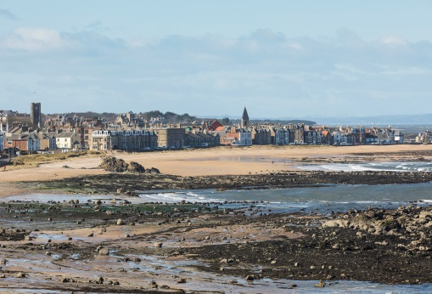The Borders Distillery is the first Scotch Whisky Distillery to operate legally since 1837. Located in the middle of Hawick, it is housed in fully restored Victorian industrial buildings. Great care was taken to preserve the built heritage of the site and many original features were retained. They have basic tour for everyone to join to making bespoke tours for customers to make the experience more exclusive.

The Borders Distillery

Commercial Road,

Hawick,

Scottish Borders,

TD9 7AQ

W: https://www.thebordersdistillery.com/distillery-tour-in-the-borders/

Day Two

Kingsbarns Distillery

Kingsbarns Distillery and Visitor Centre in the beautiful East Neuk of Fife opened its doors in December 2014. The distillery is situated between St. Andrews and Crail, close to the world famous Kingsbarns championship golf course. The historic and charming East Newhall Farm steadings situated on Cambo Estate were carefully restored and converted into a small distillery with exhibition, tasting rooms, shop and café.

Kingsbarns Distillery

East Newhall Farm,

Kingsbarns,

Fife,

KY16 8QE

W: <https://www.kingsbarnsdistillery.com/>

Eden Mill

As Scotland's first single-site distillery and brewery, making gin, whisky and beer, Eden Mill spirit is created by our distillers in copper pot-stills and exhibits a wide range of flavours from botanicals sourced from the local area, as well as from around the world. As creators of craft gin, whisky and beers, Their team of distillers have the opportunity to marry the best practices from all these disciplines.

Eden Mill

Main Street,

Guardbridge,

St Andrews,

Fife,

KY16 0US

W: <https://www.edenmill.com/>

Lindores Abbey Distillery

Lindores Abbey Distillery is a pilgrimage for the whisky lover and links to the earliest reference to Scotch whisky. After 500 years you will be able to see single malt distillation happening once again. They welcome four legged friends on their tours of the distilleries and join them for an Apothecary Experience where your clients’ inner mixologist will come to shine.

Lindores Abbey Distillery

Abbey Road,  
Newburgh,  
Fife,  
KY14 6HH

W: <https://lindores-dev.it-aces.com/>

Day Three

Royal Lochnagar Distillery

Royal Lochnagar distillery is situated on the south side of the River Dee close to Balmoral Castle. Age old traditions and craftmanship produce one of Scotland's most exclusive whiskies. A visit to Royal Lochnagar is a timeless experience. Your clients can have an exclusive tour around the distillery by the distillery manager and have a try of two exclusive craft whisky.

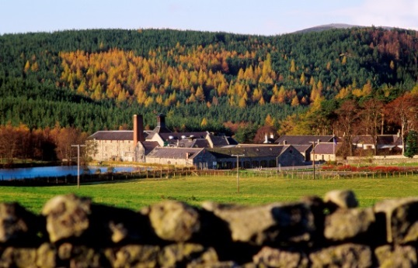

Royal Lochnagar Distillery

Crathie,

Ballater,

Aberdeenshire,

AB35 5TB

W: <https://www.malts.com/en-gb/visit-our-distilleries/royal-lochnagar/>

Glenlivet Distillery

The Glenlivet Distillery sits in a wild and remote glen, its history laced with drama and intrigue. In every bottle of whisky, they capture as much of the spirit of the glen as they can. Invite your clients to the heart of Scotland's whisky-making country to explore the turbulent history of the whisky smugglers, delve into the intriguing mysteries of distilling and sample the golden magic that is The Glenlivet. The Old malting coffee shop which has a VisitScotland “taste our best award” offering a wide range of food and drinks.

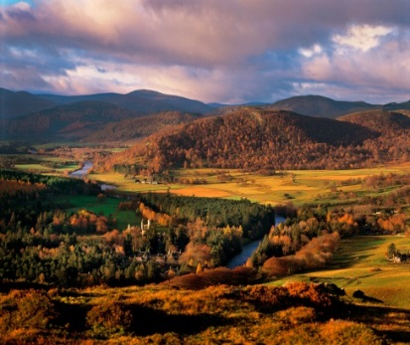

Glenlivet Distillery

Ballindalloch,

Banffshire,

AB37 9DB

W: <https://www.theglenlivet.com/en-UK>

Glenfiddich Distillery

Glenfiddich is one of the few single malt distilleries to remain entirely family owned and is now the World's Most Awarded Single Malt* Scotch Whisky, a true reflection of our founder’s innovative nature, passed down through the generations. They have four main tours they provide to see around the distillery. The Glenfiddich Solera tour will allow your clients to see how the unique solera production and step into the role of the malt master. For the whisky knowledgeable the pioneer tour allows people to take home a small sample of exclusive whisky and canapés made by chef. The Malt barn Café has their award-winning chef, Addy Daggert and his team of talented people making whisky inspired recipes with seasonal and local produce. Try their bar in The Malt Barn where your clients can taste Glenfiddich whiskies from a selection of 12 to 50-Year-Old single malts, vintage reserves and rare whiskies no longer in production.

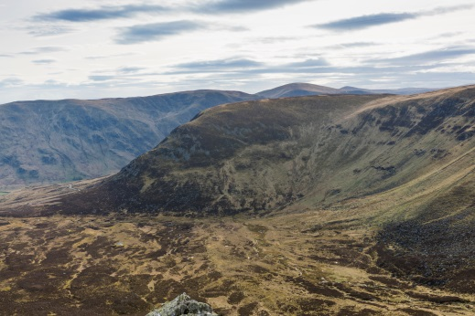

Glenfiddich Distillery

Dufftown,

Keith

AB55 4DH

W: <https://www.glenfiddich.com/uk/distillery/>

Balvenie Distillery

A tour of their distillery in Scotland is a unique experience. They like to keep things personal, so we limit each tour to a maximum of 8 people. Nestled in the picturesque surroundings of Dufftown, Speyside, your clients will see the only traditional, working floor maltings in the Scottish Highlands; meet some of their expert craftsmen; and nose and taste some of their finest malt whisky, just like their Malt Master David C. Stewart MBE.

Balvenie Distillery

Dufftown,

Keith

AB55 4BB

W: <https://www.thebalvenie.com/>

The Macallan Distillery

In the heart of the beautiful Macallan Estate, personal service and a warm greeting await every guest at the Macallan Distillery Experience. Your clients can visit the Distillery Experience at the heart of The Macallan Estate in Speyside, Scotland and get an insight into the process, production, people and passion that make our single malt whisky so special. Your clients can choose from three tour experiences - our Six Pillars Experience, Heritage Experience or Peerless Spirit Experience. The Elchies Brasserie offers Scottish produce inspired by Macallan and the local scenery.

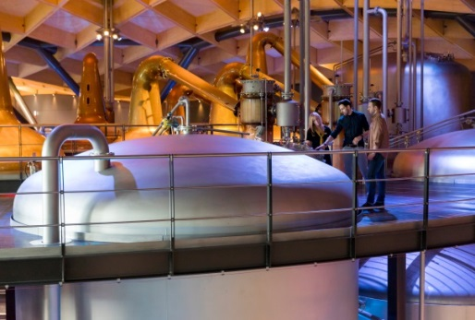

The Macallan Distillery

Easter Elchies,

Craigellachie,

Aberlour,

Moray,

AB38 9RX

W: <https://www.themacallan.com/en>

Cardhu Distillery

In 1811, John and Helen Cumming sited their first still at Cardow Farm on the Mannoch Hill, high above the River Spey. At this location spring water, naturally softened by rising up through a layer of peat, bubbled from the ground. It is alleged that Helen Cumming distilled the first gallon of Cardhu, the only malt whisky to be pioneered by a woman. For many years Helen Cumming produced only the smallest quantity of malt whisky in Cardhu's little still, as quality was her chief concern. She continued to contribute to Cardhu's success well into her 90's. Your clients can also experience the exclusively and fun of the distillery with two different tours like “Guess Dhu Tours” and “Cardhu Collection Tours”.

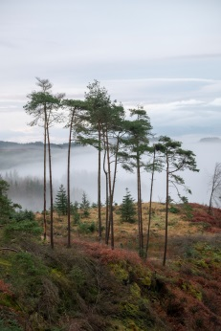

Cardhu Distillery

Knockando,

Aberlour,

Moray,

AB38 7RY

W: [www.malts.com/en-gb/visit-our-distilleries/cardhu](http://www.malts.com/en-gb/visit-our-distilleries/cardhu)

Glen Moray Distillery

A warm welcome awaits your clients at this friendly and informal working distillery in Elgin, the capital of Speyside. Glen Moray Distillery nestles on the banks of the River Lossie in the city of Elgin, the capital of Speyside, a region synonymous with malt whisky. Glen Moray Single Malt Whisky has been distilled here since 1897 by a small dedicated team of craftsmen. In over a century of distilling at Glen Moray, much has changed, however the ingredients, processes and skills of those responsible for producing Glen Moray remain constant. At Glen Moray they will provide an authentic experience of the process of whisky making with their experienced knowledgably staff making it an unforgettable experience.

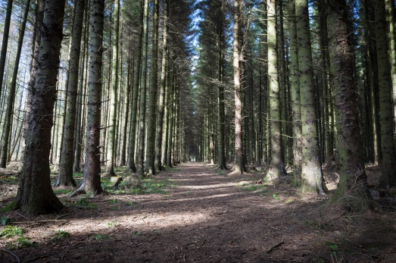

Glen Moray Distillery

Bruceland Road,

Elgin,

Moray,

IV30 1YE

W: <http://www.glenmoray.com/>

Speyside Cooperage Visitor Centre

No visit to Speyside would be complete without a stop at the Speyside Cooperage, the only cooperage in Britain with a visitor centre. In the heart of Scotland’s rolling hills lies Speyside Cooperage, the only working cooperage in the UK where you can experience the ancient art of coopering. Enjoy a journey through the lifecycle of the cask, see the highly skilled coopers at work, try it for yourself with the mini casks or simply relax and enjoy the gift and coffee shop. After your tour, explore the grounds or take lunch in the all-weather picnic area.

Speyside Cooperage Visitor Centre

Dufftown Road,

Craigellachie,

Aberlour,

Banffshire,

AB38 9RS

W: <https://www.speysidecooperage.co.uk/>

Benromach Distillery

The distillery has been making Benromach since 1898 using the same spring water rising in nearby Romach Hills. Come and see our 3 distillers at work as they orchestrate every second of the production by sight, sound and touch. One of their friendly tour guides will proudly show you around our boby mill, mash tun, 4 wooden washbacks, 2 copper stills, spirit safe, filling room, dunnage warehouses and visitor centre with many mementoes. And, of course, your clients can enjoy a tutored tasting of our gorgeous classic Speyside Single Malt Whisky.

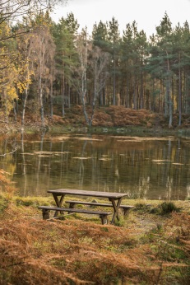

Benromach Distillery

Invererne Road,

Forres,

Morayshire,

IV36 3EB

W: <https://www.benromach.com/>

Day Four

The Craigellachie Hotel – The Quaich Bar

The Quaich, founded in 1893, is the world’s leading whisky bar. It houses over 900 single-malt whiskies from across the globe. The Quaich bar’s collection which was contributed to by renowned whisky and spirits writer, Dave Broom; author of The World Atlas of Whisky and Whisky: The Manual. It is not only significant in size, but also one of the most interesting in terms of profile. It has sought out the most unique and rare whiskies, some of which are exclusive to the Craigellachie and all of which can be sampled by the glass.

The Quaich Bar

Victoria Street,

Craigellachie,

Speyside

AB38 9SR

W: http://www.craigellachiehotel.co.uk/

Dalwhinnie Distillery

Dalwhinnie Distillery is home to a famous Highland Single Malt Whisky renowned for its gentle flavours accentuated with notes of heather honey, citrus, vanilla and sweet malt. The site of the distillery was chosen for its access to clear spring water and abundant peat from the surrounding bogs. Set in splendid mountain scenery at the heart of the Cairngorm National Park, Dalwhinnie is the highest distillery in Scotland at 1164 feet above sea level. The name Dalwhinnie is derived from the Gaelic language, meaning ‘meeting place’, referring to the meeting of ancient cattle drovers’ routes through the mountains. Your clients can take a chocolate and whisky pairing tour, this tour pairs whisky with homemade chocolate.

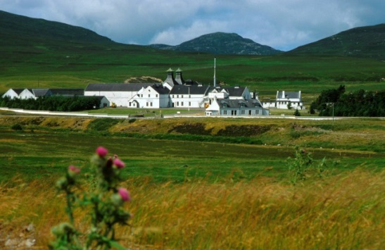

Dalwhinnie Distillery

General Wade’s Military Rd,

Dalwhinnie,

PH19 1AA

W: <https://www.malts.com/en-gb/visit-our-distilleries/dalwhinnie/>

Blair Atholl Distillery

Blair Athol Distillery stands at the gateway to the Scottish Highlands in the picturesque town of Pitlochry, Perthshire. Set in open moorland south of the town, in the foothills of the Grampian mountains, Blair Athol’s ancient source of water – the Allt Dour – flows through the grounds from the slopes of Ben Vrackie, contributing to the whisky’s mellow quality and smooth finish. Your clients can have a full day experience which includes making time speaking to head operator of the distillery, a hosted lunch and tasting whisky.

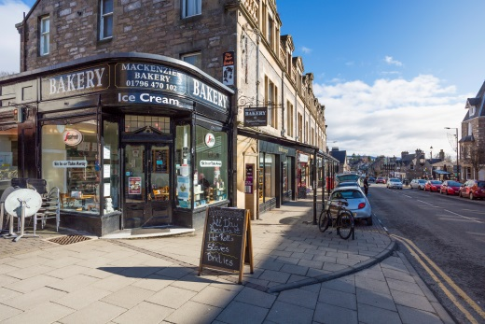

Blair Atholl Distillery

Perth Road,

Pitlochry,

Perthshire,

PH16 5LY

W: https://www.malts.com/en-gb/distilleries/blair-athol/

Edradour Distillery

Edradour Distillery is one of Scotland’s smallest distilleries, where Edradour 10-year-single malt whisky is produced. Your clients can take guided tours including a ‘taste of our whisky tour’, enjoy an audio-visual presentation and have a real insight into the traditional methods of whisky making.

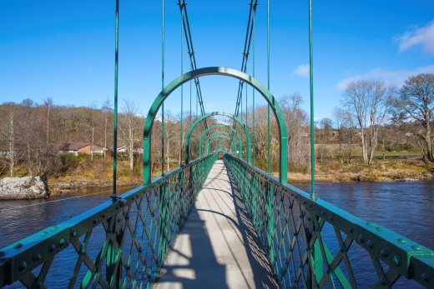Edradour Distillery

Pitlochry,

Perthshire,

PH16 5JP

W: <https://www.edradour.com/>

Dewars Aberfeldy Distillery

Enjoy a visit to the home of Dewars Whisky. This exceptionally fine distillery is located just 3 miles from the birthplace of founder John Dewar and since 1898 the stills have produced the beautifully balanced single malt at the heart of Dewar’s. Access the atmospheric warehouse and learn how they double age their whisky for extra smoothness. Explore the interactive exhibition and soak up the atmosphere in a welcoming cafe and Whisky Lounge and fill your own bottle from hand-selected casks and much more.

Dewars Aberfeldy Distillery

Aberfeldy,

Perthshire,

PH15 2EB

W: https://www.dewars.com/gl/en/aberfeldydistillery/

Glenturret Distillery

Glenturret Distillery is Scotland’s oldest working distillery that offers a range of great whisky tasting tour experiences. Set in the beautiful Perthshire countryside, Glenturret Distillery is a unique whisky experience for visitors. Glenturret Malt Whisky is still hand crafted today as it was over two centuries ago using the only remaining hand operated mash tun in Scotland. Apertour tour will allow your clients to take photos of the whisky making process as they’ll walk around with the tour.

Glenturret Distillery

The Hosh,

Crieff

PH7 4HA

W: <https://theglenturret.com/pages/age-verification?r=https://theglenturret.com/>

Deanston Distillery

Located 8 miles from Stirling, Deanston Distillery sits by the River Teith at the entrance to the dramatic Loch Lomond and Trossachs National Park. Having been a cotton mill for 180 years, Deanston was transformed into a distillery in the 1960’s and has been distilling whisky using traditional methods ever since. Your clients can experience the sights, smells and sounds of a true working distillery and they will show your clients how we hand craft our great whisky, which is sweet, fruity with a malty honeyed spiciness on the palate. The Coffee Bothy, their distillery cafe, offers a wide selection of wholesome food. Daily specials, light lunches and delicious soups are freshly made every day by our chefs. Choose also from their speciality coffees and teas and satisfy your clients sweet tooth with a scrumptious Bothy cake.

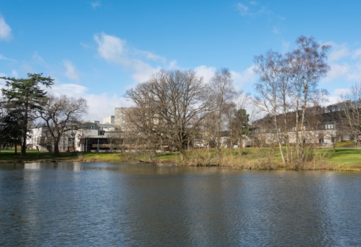

Deanston Distillery

Deanston,

Doune,

Stirlingshire,

FK16 6AG

W: <https://www.deanstonmalt.com/>

Day Five

Strathisla Distillery

At Strathisla Distillery feel closer to the true spirit of our rich, smooth, Chivas Regal blends and the classic Speyside malt at their heart. As a whisky enthusiast, or a newcomer, your Strathisla tour will be a sensory experience, both memorable and informative – created in a beautiful riverside distillery now in its two hundred and thirty second year of Scottish Highlands’ history.

Strathisla Distillery

Seafield Avenue,

Keith,

Morayshire,

AB55 5BS

W: <https://maltwhiskydistilleries.com/strathisla/age-gate>

Tullibardine Distillery

Tullibardine Distillery is located in Blackford, Perthshire - the gateway to the Scottish Highlands. Their site dates back to late 1940s as a distillery for producing hand crafted, Highland single malt Scotch whisky. Since 2011, the distillery has been under the ownership of the independent, family-owned spirits company, Terroirs Distillers. Tullibardine’s expert and experienced guides and distillery staff can give visitors a detailed insight into the craftsmanship and detail that goes into making our single malt whisky and the art of distillation.

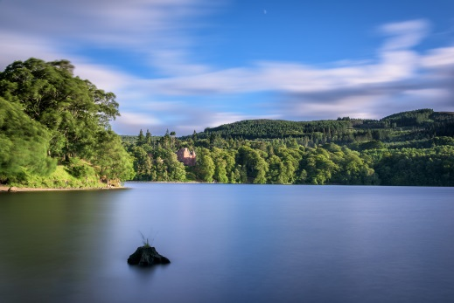

Tullibardine Distillery

Stirling Street,

Blackford,

Perthshire,

PH4 1QG

W: <https://www.tullibardine.com/>

Glengoyne Distillery

Glengoyne is open all year round for guided tours, whisky tastings, in-depth distillery visits and private dining. There is also a superb whisky shop, with a range of distillery exclusive whiskies.

Often described as Scotland's most beautiful distillery, Glengoyne is open all year for guided distillery tours, whisky tastings, special events and a superb whisky shop. The distillery is easy to reach; just 40 minutes’ drive from Glasgow or 30 minutes from Stirling and Loch Lomond.

Glengoyne Distillery

Dumgoyne,

Near Killearn,

Strathblane,

Glasgow,

G63 9LB

W: <https://www.glengoyne.com/>

Auchentoshan Distillery

Established in 1823, Auchentoshan (pronounced Ock-un-tosh-un) Distillery is on the mainland of Scotland, situated on the A82 between Glasgow and Loch Lomond. This lowlands malt distillery rests at the foot of the Kilpatrick Hills, overlooking the famous River Clyde, once renowned as the Scottish gateway to the world. Auchentoshan, meaning 'corner of the field', produces a delicate, smooth and light single malt whisky.

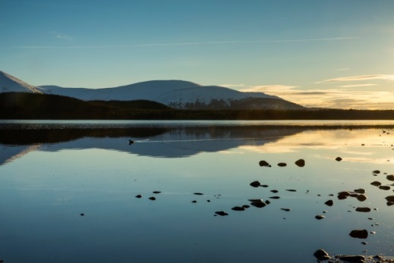

Auchentoshan Distillery

By Dalmuir,

Clydebank,

G81 4SJ

W: <https://www.auchentoshan.com/>

Once Upon a Whisky Tours

They build tours in Edinburgh and Glasgow around whisky and beer tasting in different bars around each off the cities. Your clients can take one of their Glasgow West End Whisky trails, allowing them to explore the local secrets of the west end and the treasure of whiskies your clients will be tasting.

Once Upon a Whisky Tours

1 Holyrood Crescent,

Glasgow,

G20 6HJ

W: https://onceuponawhisky.co.uk/guided-tours/glasgows-west-end-whisky-tour/

Clydeside Distillery

The Clydeside Distillery is a Single Malt Scotch Whisky distillery, visitor experience, café, and specialist whisky shop in the heart of Glasgow; Glasgow’s first dedicated Single Malt Scotch Whisky Distillery for over 100 years. Here you can choose a tour which involves chocolate paring with whisky.

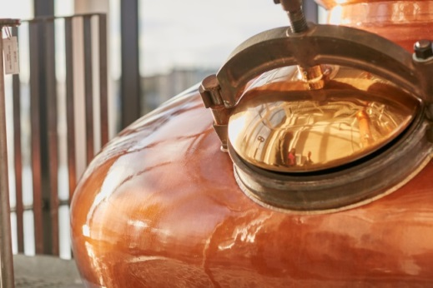

Clydeside Distillery

100 Stobcross Road,

Glasgow,

Glasgow City,

G3 8QQ

W: https://www.theclydeside.com/

Annandale Distillery

Annandale Distillery was established in 1836 and reborn in 2014 following an extensive £10.5million restoration project. Once again single malt Scotch whisky is being produced in the region after almost a 100-year sleep. Learn about the history of Annandale Distillery and how we produce fine Single Malt Scotch Whisky, and finish with a taste of Annandale’s exceptional whiskies.

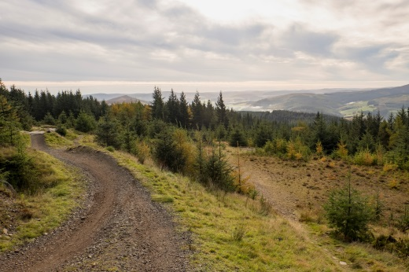

Annandale Distillery

Northfield,

Annan,

Dumfries & Galloway,

DG12 5LL

W: <https://annandaledistillery.com/>

##### A.D Rattray’s Whisky Experience & Whisky Shop

Explore Scotch whisky and its fascinating heritage when your clients visit the West Coast of Scotland, where a warm welcome awaits you at the A. D. Rattray Whisky Shop. Established in 1868, discover more about A. D. Rattray, their story, their history and their whiskies. Your clients can enjoy bespoke tasting experiences with their single cask and single malt whiskies or alternatively Scottish craft gins.

##### A.D Rattray’s Whisky Experience & Whisky Shop

32 Main Road,

Kirksowald,

Ayrshire,

KA19 8HY

W: <https://www.adrattray.com/visit-us/tastings>

VisitScotland’s Themed Years

**Year of Scotland's Coasts and Waters 2020**

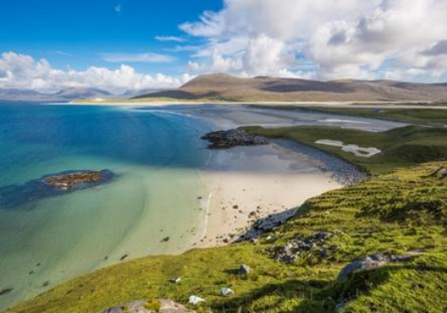In 2020, Scotland celebrates its Coasts and Waters with a year-long programme of events and activities which will shine a spotlight on these vital elements of our landscape.

From our beautiful natural features including coasts, lochs and rivers to our industrial heritage such as our canals, mills and the creation of our national drink – whisky, Scotland’s Coasts and Waters have shaped our culture, our stories and our way of life. So, whether you want to navigate your way around distant isles or canals, experience Scotland’s maritime heritage at a visitor attraction, enjoy Scotland’s abundant natural larder or discover Scotland’s wildlife on a local boat trip - Scotland’s coasts and waters are perfect for get-away-from-it-all adventures.

For more info [www.visitscotland.com/ycw2020](http://www.visitscotland.com/ycw2020) and join the conversation using #YCW2020

Year of Scotland’s Stories 2022

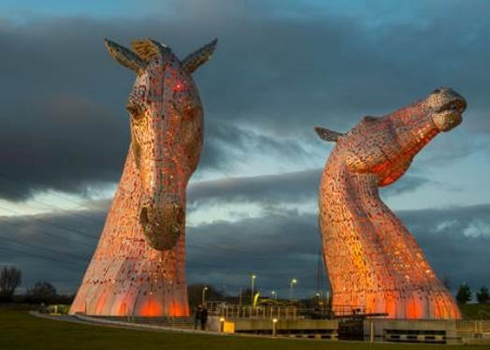The Year of Scotland’s Stories in 2022 will be a showcase of the country’s rich literature, film, oral traditions, myths and legends. Scotland has inspired writers, artists and poets for centuries.  The words of Robert Burns are known and celebrated across the world, as are works by Sir Walter Scott and Robert Louis Stevenson, while stories by modern Scottish authors, such as JK Rowling’s Harry Potter tales, are inspiring today’s generation.

The story of real-life legends such as King Robert the Bruce, Sir William Wallace, Mary Queen of Scots have inspired poems, books and even Oscar winning movies. Stories of magic, ghosts, witches, haunted castles and tales of mystical figures such as Kelpies abound, and there are the oral traditions handed down through generations in Scotland’s many diverse communities.

We invite visitors to join us in exploring the rich history of Scotland’s stories in 2022, including a programme of events which will take place across the year.

Online Resources

VisitScotland Websites

Our travel trade website offers the travel industry a one-stop-shop for Scotland information, inspiration and tool kit. The site is designed to assist tour operators and agents to sell destination Scotland more effectively to their clients.

Travel trade website [www.visitscotlandtraveltrade.com](https://traveltrade.visitscotland.org/)

Destination Education Programme [www. visitscotlandtraveltrade.com/scotsagent](https://traveltrade.visitscotland.org/scotsagent/)

VisitScotland consumer site [www.visitscotland.com](http://www.visitscotland.com)

Information on travel trade website

* Inspirational itineraries
* Downloadable e-brochures and maps
* Link to multimedia library for images and videos
* Online destination education programme
* Opt-in to receive our monthly travel trade e-newsletter.
* A comprehensive directory of Scottish companies who have committed to special rates, discounts and commissions exclusively available for the travel trade.

General websites

Britrail www.britrail.com

News & Weather information www.bbc.co.uk/weather

British Train information www.nationalrail.co.uk

Scottish Train information www.scotrail.co.uk

Bus information www.citylink.co.uk

Historic Environment Scotland www.historic-scotland.gov.uk

National Trust for Scotland www.nts.org.uk

Scottish Tourist Guides Association www.stga.co.uk