Youth Travel

SAMPLE ITINERARY

Day One

Riverside Museum

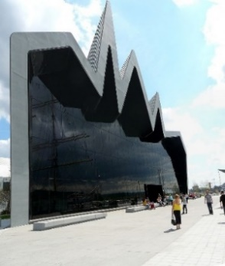Riverside Museum is Glasgow's award-winning transport museum. With over 3,000 objects on display there's everything from skateboards to locomotives, paintings to prams and cars to a Stormtrooper. Your clients can get hands on with our interactive displays, walk through Glasgow streets and visit the shops, bar and subway.

Riverside Museum

Pointhouse Place,

Glasgow,

G3 8RS

W: <http://www.glasgowlife.org.uk/museums>

Glasgow Powerboats

A unique city-centre experience. Glasgow Powerboats offer fantastic fast boat trip experiences on the River Clyde from Pacific Quay in the heart of Glasgow right outside the BBC Scotland HQ. From a 15-minute City Centre transfer to a full day down the water they can tailor trips to your clients’ itinerary. Perfect for small groups and FIT’s.

Glasgow Powerboats

50 Pacific Quay,

Glasgow,

G51 1EA

W: <https://powerboatsglasgow.com/>

Glasgow Science Centre

Glasgow Science Centre is one of Scotland's must-see visitor attractions. It has lots of activities to keep visitors of all ages entertained for hours. There are two acres of interactive exhibits, workshops, shows, activities, a planetarium and an IMAX cinema. Your clients can cast off in The Big Explorer and splash about in the Waterways exhibit, put on a puppet show and master the bubble wall. Located on the Pacific Quay in Glasgow City Centre just a 10-minute train journey from Glasgow Central Station.

Glasgow Science Centre

50 Pacific Quay,

Glasgow,

G51 1EA

W: https://www.glasgowsciencecentre.org/

Scottish Maritime Museum

Based in the West of Scotland, with sites in Irvine and Dumbarton, the Scottish Maritime Museum holds an important nationally recognised collection, encompassing a variety of historic vessels, artefacts, fascinating personal items and the largest collection of shipbuilding tools and machinery in the country. The buildings and sites which the Scottish Maritime Museum occupies are themselves part of the heritage collection.

Scottish Maritime Museum

Main Gallery & Education Room,

The Linthouse,

Harbour Road,

Ayrshire,

KA12 8BT

W: <https://www.scottishmaritimemuseum.org/irvine-museum/>

**Alpaca Trek at Netherfield Alpacas**

Netherfield Alpacas is a small family run farm in Lanarkshire which runs Alpaca trekking and breeds Alpacas. The farm can cater for groups or individuals and educates visitors on how Alpacas are cared for. Visitors also can see baby alpacas and learn about the process of making beautiful yarn from them their fleeces.

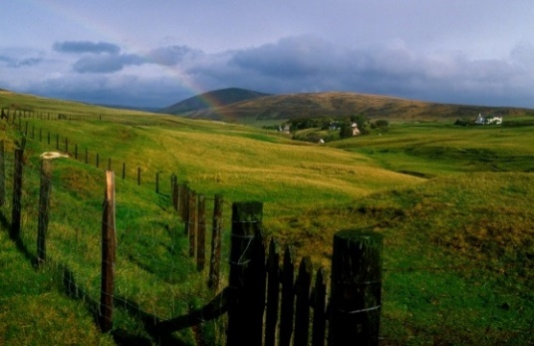

**Netherfield Alpacas**

Netherfield Farm,

Bellfield Road,

Coalburn,

Lanarkshire,

ML11 0NG

W: <https://www.newlanarkhotel.co.uk/>

Day Two

**New Lanark World Heritage Site**

The fascinating history of New Lanark World Heritage Site is brought back to life in an award-winning visitor centre. With a passport ticket your clients can explore fantastic exhibitions, including the Annie Mcleod Experience, Mill workers' houses, Robert Owen's House and school, working textiles machinery and Scotland’s largest roof garden!

**New Lanark World Heritage Site**

Lanark,  
South Lanarkshire,  
ML11 9DB

W: <https://www.newlanark.org/>

Culzean Castle

With its dramatic clifftop setting, Robert Adam architecture, fascinating history and beautiful surroundings, it is easy to see why Culzean Castle is one of Scotland’s most popular visitor attractions. Surrounded by Culzean Country Park, an extensive estate encompassing lush woodland, landscaped gardens and rugged coastline, this 18th-century Scottish castle couldn’t be better placed for a family day out. Culzean Castle and Country Park are owned and managed by the National Trust for Scotland and admission is free for members.

Culzean Castle

Maybole,

KA19 8LE

W: <http://www.nts.org.uk/Property/Culzean-Castle-and-Country-Park>

Glentrool Visitor Centre

Glentrool Visitor Centre is a tranquil spot at the heart of the forest. Your clients can nwind in the café and watch woodland birds busy on the feeders or discover the lively waters that meet at stunning Loch Trool on scenic trails beneath the mighty Merrick. This area's history is also written into the landscape – look out for Bruce's Stone nearby, overlooking the Battle of Glen Trool in 1307, and a moving monument to 17th century covenanters, slain for their religious beliefs.

Glentrool Visitor Centre

Stroan Bridge,

DG8 6SZ

W: <http://www.scotland.forestry.gov.uk/forest-parks/galloway-forest-park/red-deer-range>

Mull of Galloway Experience

At the Mull of Galloway your clients can climb the Lighthouse, visit the Exhibition of Lighthouse History, walk around the [RSPB Scotland nature reserve](http://ww2.rspb.org.uk/reserves-and-events/find-a-reserve/reserves-a-z/reserves-by-name/m/mullofgalloway/index.aspx) and enjoy delicious food and drink at Scotland’s most southerly [coffee house](http://www.galliecraig.co.uk/). Visitors can limb 115 steps to the top of the Mull of Galloway Lighthouse and, on a clear day, be rewarded with spectacular views of Scotland, Ireland, Isle of Man and Cumbria, watch the gannets diving and look out for porpoises and dolphins.

Mull of Galloway Lighthouse

Drummore,

Stranraer,

DG9 9HP

W: <http://www.mull-of-galloway.co.uk/mull-of-galloway-experience/>

Gem Rock Museum

The Gem Rock museum is a unique attraction located in Creetown. The museum has a large collection containing many fine and rare examples of crystals found in Britain. They are displayed alongside many other colourful specimens from around the world with unusual items such as the 4.5 billion-year-old, three-kilogram meteorite, the fossilised egg and much more. The museum is home to crystals, gems and minerals that can only be found there. The Gem Rock Museum is wheelchair accessible, perfect for young children and families and also has a tearoom on-site.

Gem Rock Museum

Chain Road,

Creetown,

DG8 7HJ

W: <http://www.gemrock.net/>

Day Three

Galloway Activity Centre

# The award-winning Galloway Activity Centre is situated in the heart of the Galloway Forest Park offering authentic and unique experiences on the shores of Loch Ken. A large choice of land and water-based activities are complimented by fantastic Scottish food and a range of exciting accommodation options. Activity choices from wilderness kayak trips for those wanting to explore nature, to Scotland's first 40-foot Giant 3G swing for the adrenaline junkies! Suitable for large groups.

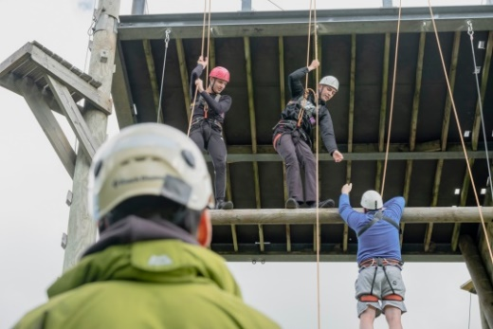

Galloway Activity Centre,  
Loch Ken,  
Castle Douglas,   
Dumfries and Galloway,   
DG73NQ

W: <http://www.lochken.co.uk/>

Mostly Ghostly

A warm welcome to the home of Mostly Ghostly Investigations – Dumfries and Galloway’s first paranormal investigation team and creators of a range of well-researched ghost and local history tours encompassing everything from Scotland’s most haunted road to an intriguing vampire legend dating back to the 12th century. We are proud winners of the 2012 & 2014 Dumfries & Galloway Life Tourism Champion Awards.

MostlyGhostly Investigations

DG2 9QD

W: https://www.visitsouthwestscotland.com/attractions/mostly-ghostly-tours/

**Several locations in Dumfries & Galloway**

Drumlanrig Castle

Immerse yourself in history and famous art at majestic Drumlanrig Castle. A five-star visitor attraction, Drumlanrig offers stunning scenery in a 90,000-acre estate. Group tours are available throughout the year. Adventures await your clients at Drumlanrig Castle, castle tours, mountain bike trails, cycling, waymarked walks, adventure playground, gardens, shop, fishing and Land Rover tours are all available in season.

Drumlanrig Castle

Thornhill,

Dumfries & Galloway,

DG3 4AQ

W: <https://www.drumlanrigcastle.co.uk/>

Moat Brae

From the ages of 13 -18, James Matthew Barrie played wild and adventurous pirate games with his friends in the ‘enchanted land’ surrounding the grand Georgian house at Moat Brae. These games were long after to provide the inspiration behind ‘that nefarious work’ – Peter Pan. The unique environment and experiences he had here in Dumfries at that time would strongly influence Barrie’s astonishingly successful writing career.

Moat Brae

George Street,  
Dumfries,

DG1 2EA

W: <http://www.peterpanmoatbrae.org/>

Day Four

Cocoa Black

Home to Ruth Hinks (UK World Chocolate Master) the multi-award-winning Cocoa Black chocolate boutique offers a delicious selection of hot chocolate drinks, patisserie, chocolates and celebration cakes. Located in the Royal Burgh of Peebles, near Edinburgh, Cocoa Black is housed in a beautiful grade 2 listed building on the banks of the River Tweed. As well as café, Cocoa Black runs a chocolate cookery school with many options for classes, experiences and activities.

Cocoa Black

1 - 2 Cuddybridge,

Peebles,

Scottish Borders,

EH45 8HX

W: <https://www.cocoablack.com/>

Glentress Forest

Glentress Forest is a mountain biking Mecca deep in the heart of the stunning Tweed Valley. The biking experience here includes Green, Blue, Red or Black graded trails, as well as a magnificent multi-graded free-ride area. The trails are free to ride and there is bike hire, accommodation, cafe, restaurant and a GoApe treetop rope course at the forest. Located two miles outside the historic Borders town of Peebles

Glentress Forest

Tweed Valley

Near Peebles

Scottish Borders

W: <https://forestryandland.gov.scot/visit/forest-parks/tweed-valley-forest-park/glentress>

Foxlake Adventures

Foxlake Adventures is Scotland’s first cable wakeboarding park along with the UK’s only ropes course constructed over water. They are located in the heart of East Lothian 25 miles east of Edinburgh, nestled in a beautiful woodland. Your clients will have much to choose from including wakeboarding, FoxFall Rope Course, a ZipTrail, woodland Off-Road Segway paths or they can just chill out on the lake side.

Foxlake Adventures

Dunbar

East Lothian

EH42 1XF

W: <https://www.foxlake.co.uk/>

Scottish Seabird Centre

A great day out at the seaside with the five-star Scottish Seabird Centre, North Berwick, only 30 minutes from Edinburgh. There are numerous activities on offer including interactive live cameras on the local islands to zoom in on the amazing wildlife in its natural habitat. Boat trips run between April and the end of September. Your clients can enjoy the wildlife in the Firth of Forth from the custom built 55 seat catamaran or the Three Islands Seabird Seafari on the fast RIB (Rigid Inflatable Boat). Further trips include Landing trips to the Isle of May and Bass Rock.

Scottish Seabird Centre

The Harbour,

North Berwick,

East Lothian,

EH39 4SS

W: <https://seabird.org/>

VisitScotland’s Themed Years

Year of Scotland's Coast and Waters 2020

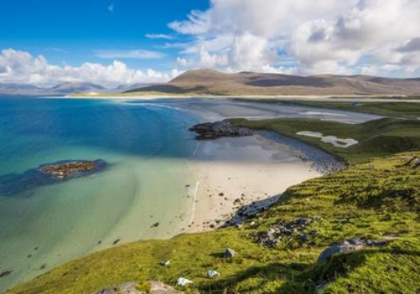In 2020 we will showcase Scotland’s marine and coastal tourism sector. Including its many islands, Scotland boasts thousands of miles of varied coastline. The diverse coastal scenery, ranging from dramatic cliffs and sea stacks to gleaming white beaches, offers an unparalleled range of experiences, including watersports, wildlife watching and island hopping to explore the numerous islands. Scotland’s lochs, rivers and canals also form an important part of the visitor experience, such as boat trips, fishing opportunities, and activity holidays, while the many nature reserves across the country are home to a tremendous variety of flora and fauna.

The ways in which Scotland’s coast and waters have shaped our history from the Industrial Revolution to the fishing and whisky industries can also be explored at a range of visitor attractions. These themes will be celebrated throughout 2020, along with a programme of events.

Year of Scotland’s Stories 2022

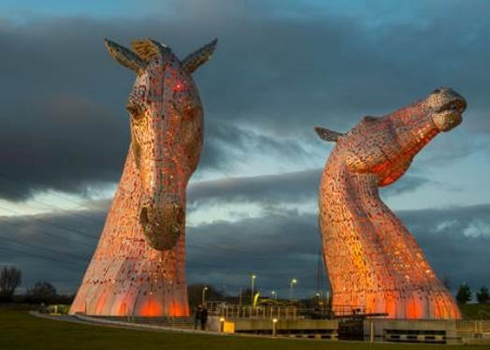The Year of Scotland’s Stories in 2022 will be a showcase of the country’s rich literature, film, oral traditions, myths and legends. Scotland has inspired writers, artists and poets for centuries.  The words of Robert Burns are known and celebrated across the world, as are works by Sir Walter Scott and Robert Louis Stevenson, while stories by modern Scottish authors, such as JK Rowling’s Harry Potter tales, are inspiring today’s generation.

The story of real-life legends such as King Robert the Bruce, Sir William Wallace, Mary Queen of Scots have inspired poems, books and even Oscar winning movies. Stories of magic, ghosts, witches, haunted castles and tales of mystical figures such as Kelpies abound, and there are the oral traditions handed down through generations in Scotland’s many diverse communities.

We invite visitors to join us in exploring the rich history of Scotland’s stories in 2022, including a programme of events which will take place across the year.

Online Resources

VisitScotland Websites

Our travel trade website offers the travel industry a one-stop-shop for Scotland information, inspiration and tool kit. The site is designed to assist tour operators and agents to sell destination Scotland more effectively to their clients.

Travel trade website [www.visitscotlandtraveltrade.com](https://traveltrade.visitscotland.org/)

SCOTS education programme [www. visitscotlandtraveltrade.com/scotsagent](https://traveltrade.visitscotland.org/scotsagent/)

VisitScotland consumer site [www.visitscotland.com](http://www.visitscotland.com)

Information on travel trade website

* Inspirational itineraries
* Downloadable e-brochures and maps
* Link to multimedia library for images and videos
* Online destination education SCOTS programme
* Opt-in to receive the specialised monthly travel trade e-newsletter.
* A comprehensive directory of Scottish companies who have committed to special rates, discounts and commissions exclusively available for the travel trade.

General websites

Britrail www.britrail.com

News & Weather information www.bbc.co.uk/weather

British Train information www.nationalrail.co.uk

Scottish Train information www.scotrail.co.uk

Bus information www.citylink.co.uk

Historic Environment Scotland www.historic-scotland.gov.uk

National Trust for Scotland www.nts.org.uk

Scottish Tourist Guides Association [www.stga.co.uk](http://www.stga.co.uk)